Part B: Rock Cycle investigation [28 marks]

|  |  |  |  |
| --- | --- | --- | --- |
| Materials : | 1 sugar cube  Foil (10cm square)  Candle | Hand lens  Wooden test tube peg  Safety glasses | White paper (10 cm square) |

Procedure, Observations and Conclusions

|  |  |  |  |  |  |
| --- | --- | --- | --- | --- | --- |
| **Procedure** | **Observations -** Describe what you see | | **Marks** | **Conclusion**  Relate your observations to the Rock Cycle | **Marks** |
| 1. Examine the sugar cube with a hand lens. | Grain size |  | ½ mark each | What rock type does this represent?  Explain why | 1  2 |
| grain shape |  |
| how close the grains are apart |  |
| are the grains cemented together |  |
| overall shape of the sample |  |
| state of matter (s,l,g) |  |
| 2. Place sugar cube on white paper square and use the back of the tongs to crush part of the cube into a powder. | Grain size |  | ½ mark each | What process in the Rock Cycle does this crushing represent?  Explain why: | 1  2 |
| grain shape |  |
| how close the grains are apart |  |
| are the grains cemented together |  |
| overall shape of the sample |  |
| state of matter (s,l,g) |  |
| 3. Fold the edges of the foil over to make a small bowl. Pour the crushed sugar into the foil bowl. | :::stock-photo-cup-of-coffee-and-dissolving-sugar-lump-38723950.jpgWhat process in the Rock Cycle does the **movement** from place to place, of the crushed sugar represent?  Explain why and how: | | | | 1  2 |
| 4. Use the metal tongs to hold the bowl over the candle flame. Write down what your observations are as the sugar begins to melt. | What process in the Rock Cycle does this represent?  Explain **how** this comes about in the Rock Cycle | | | | 1  2 |
| 5. Set the foil bowl aside and let the sugar cool and harden. Write down what your observations are as the liquid begins to cool. | Grain size |  | ½ mark each | What process in the Rock Cycle does this represent?  Explain **how** this comes about in the Rock Cycle. | 1  2 |
| grain shape |  |
| how close the grains are apart |  |
| are the grains cemented together |  |
| overall shape of the sample |  |
| state of matter (s,l,g) |  |
| 6.Break the hardened sugar into pieces by crumpling the cooled foil a little. Write down what your observations are as the sugar begins to break up. | What process in the Rock Cycle does this represent?  What is produced from this process in the Rock Cycle?  What do you notice about what we did in step 2, and what we did in step 6?  What does this say about what happens to rocks? | | | | 1  1  1  1 |
|  | TOTAL: 28 | | 9 |  | 19 |

Part C: Rock Identification [9 marks]

1. Label each of the 3 Rock samples shown below (Igneous, Sedimentary or Metamorphic). (3 marks)

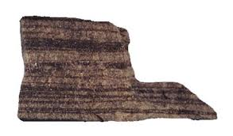

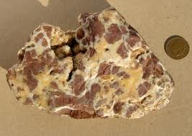

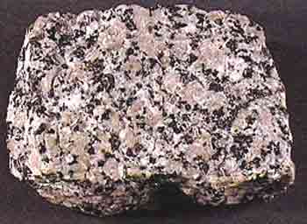

1. Accompany your choice with **two** reasons why you think it belongs in that category (what features does it have that helps you classify it). (6 marks)

|  |  |  |  |  |
| --- | --- | --- | --- | --- |
|  |  |  |  |  |